Environment vs. Economy: The Relationship Between CO2 Per Capita And Other Indicators and The Environmental Kuzents Curve

STAT 512: Final Project

Frances Lin

5/2019

## I. INTRODUCTION

In recent century, concentration of carbon dioxide (CO2) has surged to the level that has never been seen in the recorded history, and climate change remains an increasingly, if not the most, urgent issue (IPCC, 2018). It is no wonder that the “environment vs. economy” question has been a debate for many in both non-academic and academic settings such as policy research, economics, and environmental science. In economics, a prominent hypothesis called the environmental Kuznets Curve (EKC), which postulates that environmental degradation and GDP per capita form an inverted-U shape, has been proposed (Kuznets, 1955). To put it simply, EKC postulates that as a country’s economy emerges, its environment deteriorates; and, as the country’s economy advances, its environment improves. However, later studies not only disagreed on the methods and indicators used to test the EKC hypothesis (Grossman & Krueger, 1991; Shafik & Bandyopadhyay, 1992; Selden & Song, 1994; Das Neves Almeida, et al., 2017), but even similar methods and indicators were used in the studies, they showed mixed EKC results (Shafik & Bandyopadhyay, 1992; Galeotti, 2007; Budhi & Widodo, 2019).

The purpose of the study is to investigate the relationship between key economic and environmental indicators. While many studies have argued that single and even composite environmental indicator alone cannot capture the scope and complexity of the ecosystem (Das Neves Almeida, et al., 2017), for simplicity reason, this study will fit a multiple linear regression model using CO2 per capita as the main response to test and Gross Domestic Product (GDP) per capita, Gross National Income (GNI) per capita, energy use per capita, and electric power consumption per capita as the main predictors of interest. It will then fit a one-variable polynomial regression model using CO2 per capita as the main response variable and GDP per capita as the only predictor of interest to test the inverted-U-shaped EKC. The results of the study will help disentangle the relationship between economic growth and environmental impact, which can be used to inform economic and environmental policy and practice.

## II. DATA DESCRIPTION

Data were extracted from the World Bank (WB) database (World Bank, 2019), which included CO2 per capita, GDP per capita, GNI per capita, energy use per capita, and electric power consumption per capita for a total of 264 countries (n=264). CO2 per capita is the main response to test, and GDP per capita, GNI per capita, energy use per capita, and electric power consumption per capita are the main predictors of interest. All response and predictor variables are continuous.

The WB database contains data compiled as early as 1960 to 2014 (World Bank, 2019). For simplicity reason, only data compiled in 2014 were used. CO2 per capita was measured in metric tons (mt) per capita, which ranges from 0.0449 to 45.42324 metric tons per capita. A total of 250 (264-14) observations were used. GDP per capita was measured in current US$ per capita. It was calculated by dividing GDP in 2013 by midyear population of the same year, which ranges from 273.5 to 185152.5 current US$ per capita. A total of 249 (264-15) observations were used. Energy use per capita was measured in kilogram (kg) of oil equivalent per capita. It ranges from 60.73 to 18562.67 kg of oil equivalent per capita. A total of 175 (264-89) observations were used. Electric power consumption per capita was measured in kilowatt hour (kWh) per capita. It ranges from 38.97 to 53832.48 kWh per capita. A total of 182 (264-82) observations were used. GNI per capita was measured in current US$ per capita. It was calculated by dividing GNI in 2013 by midyear population of the same year using the Atlas method, which ranges from 260 to 104540 current US$ per capita. A total of 236 (264-28) observations were used.

## III. SUMMARY STATISTICS AND GRAPHICS

**Table 1(a). Descriptive Statistics**

Variable:CO2.per.capita

## Min. 1st Qu. Median Mean 3rd Qu. Max. NA's   
## 0.04449 0.88165 3.15330 4.87489 6.36518 45.42324 14

Variable: GDP.per.capita

## Min. 1st Qu. Median Mean 3rd Qu. Max. NA's   
## 273.5 2036.9 6429.0 16261.6 17061.3 185152.5 15

Variable: Energy.use.per.capita

## Min. 1st Qu. Median Mean 3rd Qu. Max. NA's   
## 60.73 682.88 1538.26 2489.09 2995.52 18562.67 89

Variable: Electric.power.per.capita

## Min. 1st Qu. Median Mean 3rd Qu. Max. NA's   
## 38.97 776.77 2514.42 3965.61 5112.80 53832.48 82

Variable: GNI.per.capita

## Min. 1st Qu. Median Mean 3rd Qu. Max. NA's   
## 260 1888 6150 13786 14678 104540 28

**Table 1(b). Descriptive Statistics: Log-Transform**

Variable: logCO2.per.capita

## Min. 1st Qu. Median Mean 3rd Qu. Max. NA's   
## -3.1126 -0.1260 1.1480 0.8144 1.8508 3.8160 14

Variable:logGDP.per.capita

## Min. 1st Qu. Median Mean 3rd Qu. Max. NA's   
## 5.611 7.619 8.769 8.778 9.745 12.129 15

Variable:logEnergy.use.per.capita

## Min. 1st Qu. Median Mean 3rd Qu. Max. NA's   
## 4.106 6.526 7.338 7.342 8.005 9.829 89

Variable: logElectric.power.per.capita

## Min. 1st Qu. Median Mean 3rd Qu. Max. NA's   
## 3.663 6.655 7.830 7.561 8.539 10.894 82

Variable: logGNI.per.capita

## Min. 1st Qu. Median Mean 3rd Qu. Max. NA's   
## 5.561 7.543 8.724 8.686 9.594 11.557 28

**Figure 1. Pairwise Scatterplots**

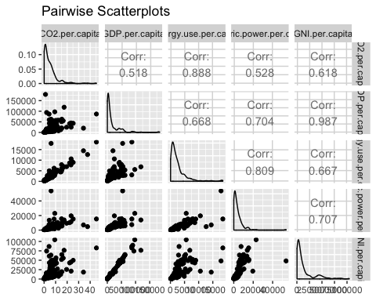

**Figure 2. Pairwise Scatterplots: Log-Transform**

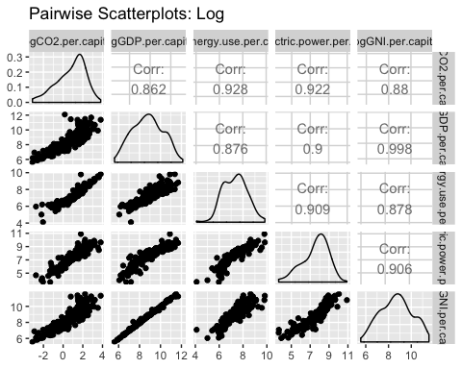

## 

## IV. ANALYSIS

The study started out by computing a correlation matrix, plotting pairwise scatterplots (Figure 1.), log-transforming all response and predictor variables and repeat the process (Figure 2.), and implementing simple linear regression models with log-transformation. The main part of the analysis began as it implemented the multiple linear regression model with interaction. Due to data missingness for energy use per capita and electric power consumption per capita, this study did not seek methods for model selection, although there are techniques for handling missing data. Instead, it implemented the one-variable polynomial regression model to fit the EKC.

During the exploratory data analysis, pairwise scatterplots showed nonlinear relations and right skewness, so log-transformation was implemented for all response and predictor variables. However, even after the log-transformation, pairwise scatterplots showed collinearity between all predictor variables, and diagnostic plots showed unequal variances for all predictor variables (See the SUPPLEMENT section). This indicated that the simple linear regression model each on its own is overly simplified, so the multiple linear regression model was implemented.

For the first part of the analysis, the log-log multiple linear regression model was implemented. As expected, GDP per capita and GNI per capita were highly corrected (r=0.998), as GNI was calculated by GDP plus income of the country’s residents from abroad (World Bank, 2019). This log-log multiple linear regression model used logCO2 per capita as the main response variable and logGDP per capita, log energy use per capita, and log electric power consumption per capita as the main predictors of interest. The log-log multiplicative model was implemented first, and model assumptions were satisfied. Specifically, plot of Residuals vs Fitted showed equal variance, and plot of Normal Q-Q indicated normality (See the SUPPLEMENT section). Because the interaction terms were significant, the log-log additive model was not implemented. The log-log multiplicative regression model is as followed:

*logY= β0 + β1(logX1)+ β2(logX2) + β3(logX3) + β4(logX1*logX2) + β5(logX1*logX3) + β6(logX2*logX3) + β7(logX1*logX2*logX3) + 𝜀*

where Y=CO2 per capita, X1=GDP per capita, X2=Energy use per capita, and X3=Electric power per capita.

However, there were too many missing values for two of the predictor variables. Specifically, 90 out of 264 energy use per capita values and 83 out of 264 electric power consumption per capita were deleted due to missingness. In addition, past studies overwhelmingly found that either quadratic or cubic regression model using single economic indicator fit the EKC the best (Stern, 2004). For the reasons above, the study did not implement methods for model selection. Instead, the log-log one-variable polynomial regression model, which is considered a special case of multiple linear regression models, was implemented for the second part of the analysis. This log-log one-variable polynomial regression model used logCO2 per capita as the main response variable and logGDP per capita as the only predictor of interest, and model assumptions were satisfied for the quadratic and cubic regression model (See the SUPPLEMENT section). The log-log quadratic and cubic regression model are as followed:

*logY = β0 + β1(logX1) + β2 (logX1)2 + 𝜀* and

*logY = β0 + β1(logX1) + β2 (logX1)2 + β3 (logX1)3 + 𝜀*

where Y=CO2 per capita and X1=GDP per capita.

## V. RESULTS AND CONCLUSIONS

The results of the log-log multiplicative multiple linear regression model show that the model fits the data well (R2=0.9453, Adj R2=0.9429, F-test=399.9, and p=< 2.2e-16). The model explains 94.29 % of the variability, and the three-way and two-way interaction terms are all significant. Specifically, the three-way interaction term is significant (p=4.96e-05 ***), which indicates that the effect of log CO2 per capita (X1) on log CO2 per capita (Y) depends on the jointed effect of log energy use per capita (X2) and log electric power consumption per capita (X3). To put it another way, log energy use per capita (X2) on log CO2 per capita (Y) depends on the effect of log electric power consumption per capita (X3) across levels of log CO2 per capita (X1), and vice versa. In addition, predicted CO2 per capita (Y) across levels of log CO2 per capita (X1), for example, can be calculated by:

*logY = (10.02204 - 4.14913 (logX2) - 0.51888(logX3) + 0.44001(logX2*logX3)) + (-1.80515 + 0.56539(logX2) + 0.06119(logX3) + -0.04805(logX2*logX3)) (logX1) + 𝜀.*

**Table 2. the log-log multiplicative model**

(Y=CO2 per capita, X1=GDP per capita, X2=Energy use per capita, and X3=Electric power per capita.)

## Coefficients:

## Estimate Std. Error t value Pr(>|t|)   
## (Intercept) 10.02204 5.73797 1.747 0.0826

## X1 -1.80515 0.76596 -2.357 0.0196 *

## X2 -4.14913 0.93012 -4.461 1.52e-05 ***

## X3 -0.51888 0.68630 -0.756 0.4507

## X1:X2 0.56539 0.11867 4.764 4.18e-06 ***

## X1:X3 0.06119 0.08311 0.736 0.4627

## X2:X3 0.44001 0.09860 4.462 1.51e-05 ***

## X1:X2:X3 -0.04805 0.01152 -4.170 4.96e-05 ***

## ---  
## Signif. codes: 0 '***' 0.001 '**' 0.01 '*' 0.05 '.' 0.1 ' ' 1  
##   
## Residual standard error: 0.2985 on 162 degrees of freedom  
## (94 observations deleted due to missingness)  
## Multiple R-squared: 0.9453, Adjusted R-squared: 0.9429   
## F-statistic: 399.9 on 7 and 162 DF, p-value: < 2.2e-16

The results of the log-log one-variable polynomial regression model show that the log-log quadratic and cubic model fit the data well (R2=0.822, Adj R2=0.8205, F-test=545, and p=< 2.2e-16 for the quadratic model; R2=0.826, Adj R2=0.8238, F-test=372, and p=< 2.2e-16 for the cubic model). The log-log quadratic model explains 82.05% of the variability, the quadratic term is significant (p=<2e-16 ***), and model assumptions are satisfied (See the SUPPLEMENT section). The log-log cubic model explains 82.38% of the variability, the cubic term is significant (p=0.0203 *), and model assumptions are satisfied (See the SUPPLEMENT section). In addition, for the log-log linear model, a 1% increase in GDP per capita is associated with CO2 per capita multiplies by 2.418385 (e^0.8831). For the log-log quadratic model, predicted CO2 per capita can be calculated by:

*logY = -20.76289 + 4.12514 (logX1) - 0.18528 (logX1)2 + 𝜀.*

For the log-log cubic model, predicted CO2 per capita can be calculated by:

*logY = -3.91437 - 1.87669(logX1) + 0.51313(logX1)2 - 0.02658 (logX1)3 + 𝜀.*

**Table 3(a). the log-log linear model**

(Y=log CO2 per capita and X=log GDP per capita)

## Coefficients:  
## Estimate Std. Error t value Pr(>|t|)   
## (Intercept) -6.9441 0.2977 -23.32 <2e-16 ***  
## logGDP.per.capita 0.8831 0.0337 26.21 <2e-16 ***  
## ---  
## Signif. codes: 0 '***' 0.001 '**' 0.01 '*' 0.05 '.' 0.1 ' ' 1  
##   
## Residual standard error: 0.7295 on 237 degrees of freedom  
## (25 observations deleted due to missingness)  
## Multiple R-squared: 0.7434, Adjusted R-squared: 0.7424   
## F-statistic: 686.8 on 1 and 237 DF, p-value: < 2.2e-16

**Table 3(b). the log-log quadratic model**

(Y=log CO2 per capita and X=log GDP per capita)

## Coefficients:  
## Estimate Std. Error t value Pr(>|t|)   
## (Intercept) -20.76289 1.37655 -15.08 <2e-16 ***  
## logGDP.per.capita 4.12514 0.31889 12.94 <2e-16 ***  
## I(logGDP.per.capita^2) -0.18528 0.01815 -10.21 <2e-16 ***  
## ---  
## Signif. codes: 0 '***' 0.001 '**' 0.01 '*' 0.05 '.' 0.1 ' ' 1  
##   
## Residual standard error: 0.6089 on 236 degrees of freedom  
## (25 observations deleted due to missingness)  
## Multiple R-squared: 0.822, Adjusted R-squared: 0.8205   
## F-statistic: 545 on 2 and 236 DF, p-value: < 2.2e-16

**Table 3(c). the log-log cubic model**

(Y=log CO2 per capita and X=log GDP per capita)

## Coefficients:  
## Estimate Std. Error t value Pr(>|t|)   
## (Intercept) -3.91437 7.34058 -0.533 0.5944   
## logGDP.per.capita -1.87669 2.58871 -0.725 0.4692   
## I(logGDP.per.capita^2) 0.51313 0.29953 1.713 0.0880 .  
## I(logGDP.per.capita^3) -0.02658 0.01138 -2.336 0.0203 *  
## ---  
## Signif. codes: 0 '***' 0.001 '**' 0.01 '*' 0.05 '.' 0.1 ' ' 1  
##   
## Residual standard error: 0.6032 on 235 degrees of freedom  
## (25 observations deleted due to missingness)  
## Multiple R-squared: 0.826, Adjusted R-squared: 0.8238   
## F-statistic: 372

**Figure 3. The EKC: Original Scale**

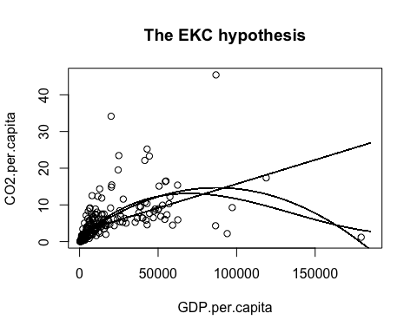

**Figure 4. The EKC: Log-Transform**

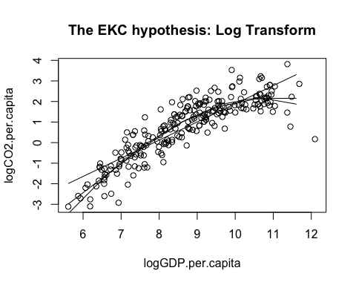

To conclude, the log-log multiplicative multiple linear regression model shows that the effect of log CO2 per capita (X1) on log CO2 per capita (Y) depends on the jointed effect of log Energy use per capita (X2) and log Electric power per capita (X3), and vice versa. On the other hand, neither the one-variable polynomial regression model nor the log-log one-variable polynomial regression model provides sufficient evidence to support the EKC. The linear, quadratic, and cubic models conform to the inverted-U-shaped EKC; however, the models do not fit well (Figure 3). On the other hand, the log-log linear, quadratic, and cubic models do not conform to the EKC (Figure 4). Or, if they do conform, the turning points are both pretty high (at approx. 11 current US $), even though the log-log quadratic and cubic model fit well and satisfy model assumptions (See the SUPPLEMENT section). Future studies should consider using environmental indicator other than CO2 per capita to fit the multiple regression models, including other potential confounding variables such as trade and level of development to fit the analysis of covariance (ANCOVA) models, or using GNI per capita as the only predictor of interest to fit the polynomial regression models.

## REFERENCES

Galeotti, M. (2007). Economic growth and the quality of the environment: taking stock. *Environment, Development and Sustainability, 9*, 427-454.

Budhi Utomo, G., & Widodo, T. (2019). The Environmental Kuznets Curve in ASEAN: The Case of Carbon Emissions.

das Neves Almeida, T. A., Cruz, L., Barata, E., & García-Sánchez, I. M. (2017). Economic growth and environmental impacts: An analysis based on a composite index of environmental damage. *Ecological Indicators, 76*, 119-130.

Grossman, G. M., & Krueger, A. B. (1991). Environmental impacts of a North American Free Trade Agreement. *National Bureau of Economic Research Working Paper 3914*, NBER, Cambridge MA.

IPCC. (2018). Global warming of 1.5°C. An IPCC Special Report on the impacts of global warming of 1.5°C above pre-industrial levels and related global greenhouse gas emission pathways, in the context of strengthening the global response to the threat of climate change, sustainable development, and efforts to eradicate poverty [V. Masson-Delmotte, P. Zhai, H. O. Pörtner, D. Roberts, J. Skea, P.R. Shukla, A. Pirani, W. Moufouma-Okia, C. Péan, R. Pidcock, S. Connors, J. B. R. Matthews, Y. Chen, X. Zhou, M. I. Gomis, E. Lonnoy, T. Maycock, M. Tignor, T. Waterfield (eds.)].

Kuznets, S. (1955). Economic growth and income inequality. *American Economic Review, 49*, 1–28.

Shafik, N., & Bandyopadhyay, S. (1992). Economic Growth and Environmental Quality: Time Series and Crosscountry Evidence. *Background Paper for the World Development Report 1992, The World Bank*, Washington, DC.

Selden, T. M., & Song, D. (1994). Environmental quality and development: Is there a Kuznets curve for air pollution? *Journal of Environmental Economics and Management, 27*, 147–162.

Stern, D. I. (2004). The rise and fall of the environmental Kuznets curve. *World development*, 32(8), 1419-1439.

World Bank, World Development Indicators. (2019). *CO2 emissions (metric tons per capita).*

World Bank, World Development Indicators. (2019). *GDP per capita (current US$).*

World Bank, World Development Indicators. (2019). *GNI per capita, Atlas method (current US$).*

World Bank, World Development Indicators. (2019). *Electric power consumption (kWh per capita).*

World Bank, World Development Indicators. (2019). *Energy use (kg of oil equivalent per capita).*

## R CODE

library(dplyr)

library(car)

library(GGally)

library(ggplot2)

WBData <- read.csv(file.choose(), header=TRUE)

str(WBData)

#View(WBData)

# Attach data set

attach(WBData)

# Log Transform all Y and Xs

logCO2.per.capita <- log(CO2.per.capita)

logGDP.per.capita <- log(GDP.per.capita)

logEnergy.use.per.capita <- log(Energy.use.per.capita)

logElectric.power.per.capita <- log(Electric.power.per.capita)

logGNI.per.capita <- log(GNI.per.capita)

# Create a new data frame: log

logWBData <- data.frame(logCO2.per.capita, logGDP.per.capita,

logEnergy.use.per.capita, logElectric.power.per.capita,

logGNI.per.capita)

str(logWBData)

#View(logWBData)

# Attach data set

attach(logWBData)

# Descriptive Statistics: original scale, log

summary(CO2.per.capita)

summary(GDP.per.capita)

summary(Energy.use.per.capita)

summary(Electric.power.per.capita)

summary(WBData$GNI.per.capita)

summary(logCO2.per.capita)

summary(logGDP.per.capita)

summary(logEnergy.use.per.capita)

summary(logElectric.power.per.capita)

summary(logGNI.per.capita)

# Pairwise Scatterplots using ggplot2

ggpairs(WBData[, -1]) + ggtitle("Pairwise Scatterplots")

# Pairwise Scatterplots using ggplot2: log

ggpairs(logWBData) + ggtitle("Pairwise Scatterplots: Log")

# Fit simple linear regression model: log

lmX1L <- lm(logCO2.per.capita~logGDP.per.capita)

summary(lmX1L)

lmX2L <- lm(logCO2.per.capita~logEnergy.use.per.capita)

summary(lmX2L)

lmX3L <- lm(logCO2.per.capita~logElectric.power.per.capita)

summary(lmX3L)

lmX4L <- lm(logCO2.per.capita~logGNI.per.capita)

summary(lmX4L)

# Diagnostic plots

par(mfrow=c(2, 2))

plot(lmX1L)

plot(lmX2L)

plot(lmX3L)

plot(lmX4L)

# Part I analysis

# Fit multiple linear regression model: log, w/ interaction

lmMInteract <- lm(logCO2.per.capita~logGDP.per.capita*

logEnergy.use.per.capita*logElectric.power.per.capita)

summary(lmMInteract)

plot(lmMInteract)

# Fit multiple linear regression model: log, no interaction

#lmM <- lm(logCO2.per.capita~logGDP.per.capita+logEnergy.use.per.capita

# +logElectric.power.per.capita)

#summary(lmM)

#plot(lmM)

# Fit multiple linear regression model: log, drop logGDP.per.capita

#lmM2 <- lm(logCO2.per.capita~logEnergy.use.per.capita+logElectric.power.per.capita)

#summary(lmM2)

#plot(lmM2)

# Part II analysis

# Fit linear, quadratic, and cubic reg model: test the EKC hypotheis

par(mfrow=c(1, 1))

plot(CO2.per.capita~GDP.per.capita,

main="The EKC hypothesis")

lmEKC1 <- lm(CO2.per.capita~GDP.per.capita)

summary(GDP.per.capita)

Xnew <- seq(from=273.5, to=185152.5)

Yhat1 <- predict(lmEKC1, list(GDP.per.capita=Xnew))

lines(Yhat1~Xnew)

lmEKC2 <- lm(CO2.per.capita~GDP.per.capita+I(GDP.per.capita^2))

Xnew <- seq(from=273.5, to=185152.5)

Yhat2 <- predict(lmEKC2, list(GDP.per.capita=Xnew))

lines(Yhat2~Xnew)

lmEKC3 <- lm(CO2.per.capita~GDP.per.capita+I(GDP.per.capita^2)++I(GDP.per.capita^3))

Xnew <- seq(from=273.5, to=185152.5)

Yhat3 <- predict(lmEKC3, list(GDP.per.capita=Xnew))

lines(Yhat3~Xnew)

#summary(lmEKC1)

#summary(lmEKC2)

#summary(lmEKC3)

#par(mfrow=c(2, 2))

#plot(lmEKC1)

#plot(lmEKC2)

#plot(lmEKC3)

#Fit linear, quadratic, and cubic reg model: test the EKC hypotheis, log

par(mfrow=c(1, 1))

plot(logCO2.per.capita~logGDP.per.capita,

main="The EKC hypothesis: Log Transform")

lmEKC1Log <- lm(logCO2.per.capita~logGDP.per.capita)

summary(logGDP.per.capita)

Xnew <- seq(from=5.611, to=12.129)

Yhat1 <- predict(lmEKC1Log, list(logGDP.per.capita=Xnew))

lines(Yhat1~Xnew)

lmEKC2Log <- lm(logCO2.per.capita~logGDP.per.capita+I(logGDP.per.capita^2))

Xnew <- seq(from=5.611, to=12.129)

Yhat2 <- predict(lmEKC2Log, list(logGDP.per.capita=Xnew))

lines(Yhat2~Xnew)

lmEKC3Log <- lm(logCO2.per.capita~logGDP.per.capita+I(logGDP.per.capita^2)++I(logGDP.per.capita^3))

Xnew <- seq(from=5.611, to=12.129)

Yhat3 <- predict(lmEKC3Log, list(logGDP.per.capita=Xnew))

lines(Yhat3~Xnew)

summary(lmEKC1Log)

summary(lmEKC2Log)

summary(lmEKC3Log)

par(mfrow=c(2, 2))

plot(lmEKC1Log)

plot(lmEKC2Log)

plot(lmEKC3Log)

## SUPPLEMENTS

**Diagnostic Plot 1(a). the log-log simple linear regression model**

(Y=logCO2.per.capita, X=logGDP.per.capita)

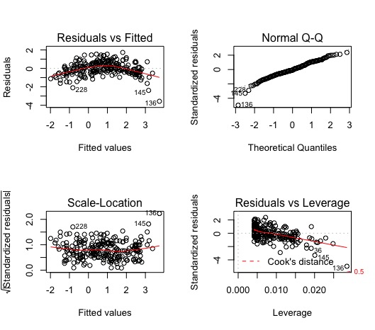

**Diagnostic Plot 1(b). the log-log simple linear regression model**

(Y=logCO2.per.capita, X=logEnergy.use.per.capita)

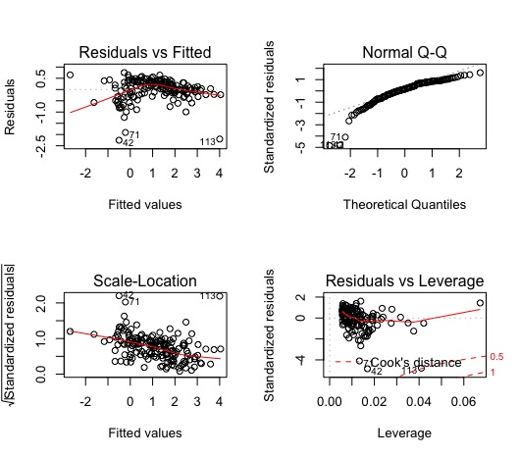

**Diagnostic Plot 1(c). the log-log simple linear regression model**

(Y=logCO2.per.capita, X=logElectric.power.per.capita)

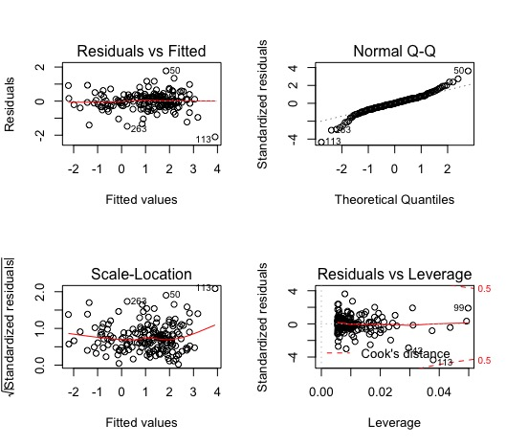

**Diagnostic Plot 1(d). the log-log simple linear regression model**

(Y=logCO2.per.capita, X=logGNI.per.capita)

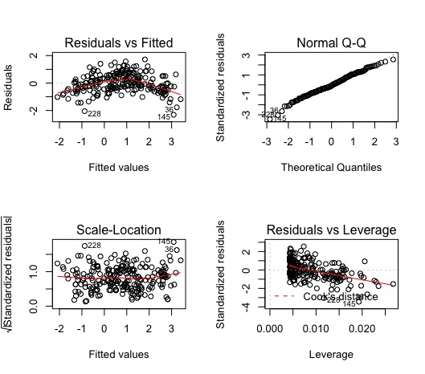

**Diagnostic Plot 2. the log-log multiplicative model, w/ interaction**

(Y=CO2 per capita, X1=GDP per capita, X2=Energy use per capita, X3=Electric power per capita.)

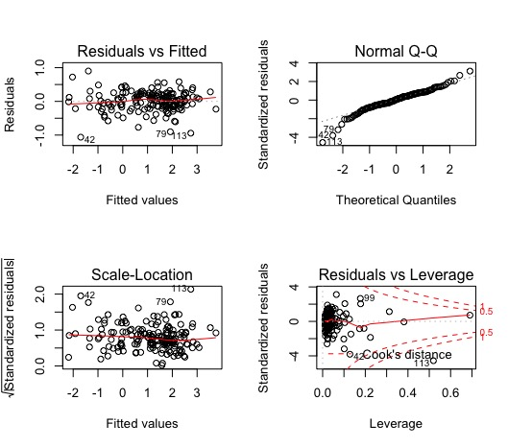

**Diagnostic Plot 3(a). the log-log one-variable linear model**

(Y=logCO2.per.capita, X=logGDP.per.capita)

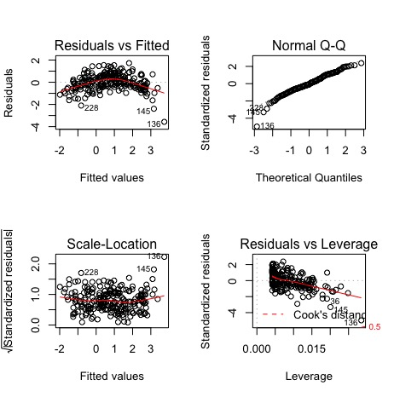

**Diagnostic Plot 3(b). the log-log one-variable quadratic model**

(Y=logCO2.per.capita, X=logGDP.per.capita)

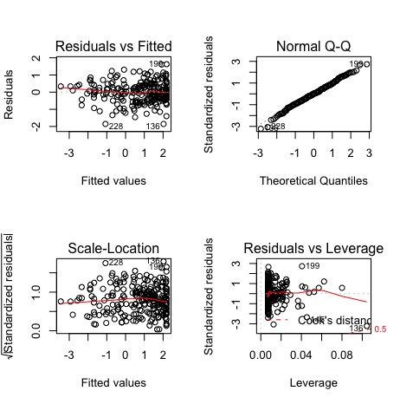

**Diagnostic Plot 3(c). the log-log one-variable cubic model**

(Y=logCO2.per.capita, X=logGDP.per.capita)

